#StayInWorkOut Challenges

BPSS REPORTERS

Date: 11.6.20 Challenge Completed: Various

Report Title: My daily workouts!
It is the 80’th day of lockdown and I am still doing my daily exercise- come on and I can talk you through it…

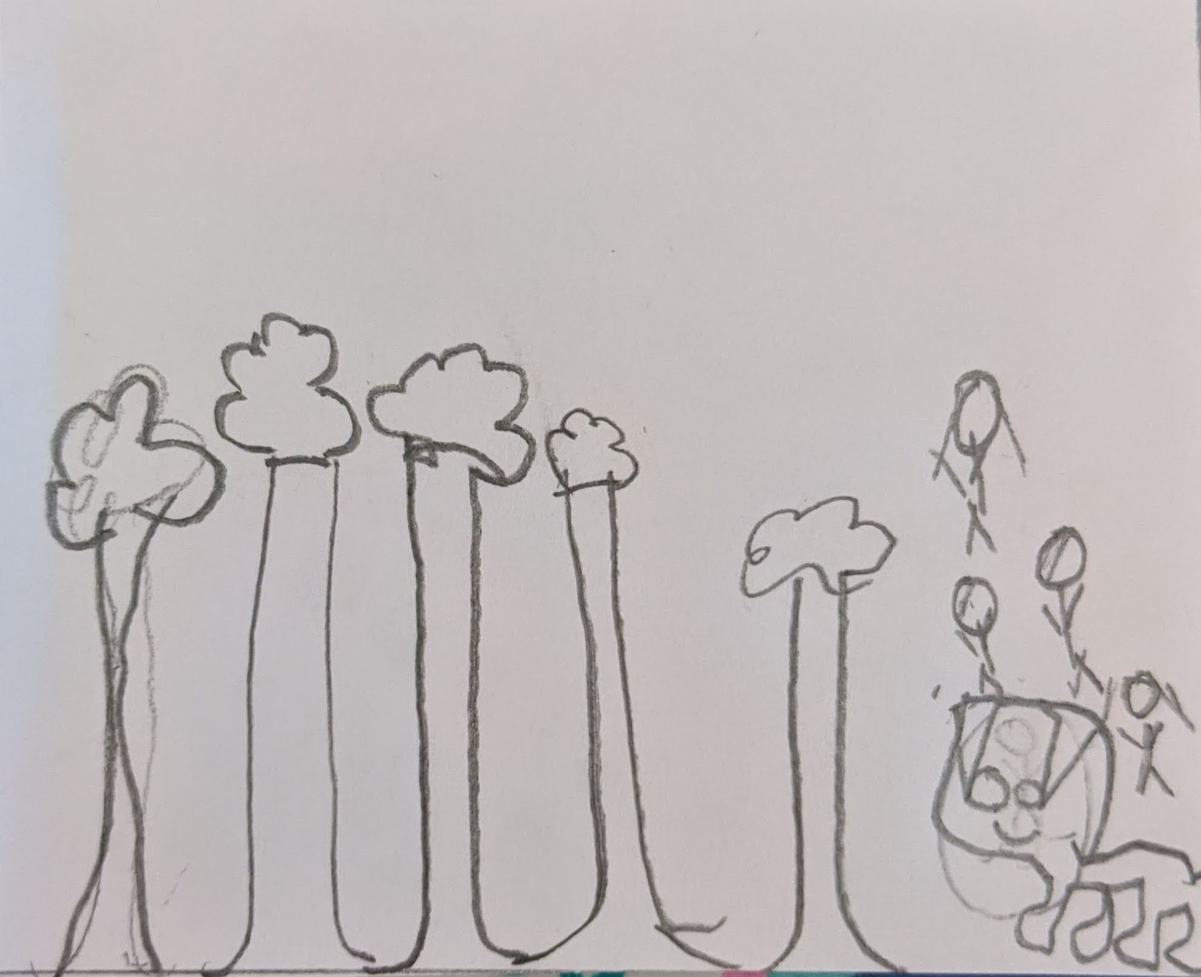
Insert drawing
So first I go on an early morning dog walk usually at 8 ‘o clock, then I do my joe Wicks, then I go on another dog walk but longer for about 2 and a half hours, sometimes I go on a bike ride too! Then it is relaxing time, but I usually practice my headstands during relax time!

That is my daily exercise- Bye!

Also, guess what? My brother and I have walked more than Land’s End to John o Groats- Wow!

First Name: Y3 Pupil School: Livingstone Primary and Nursery School

