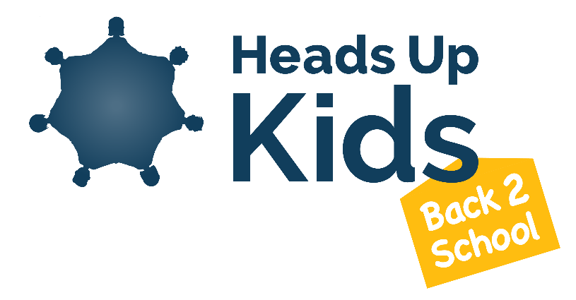
- Heads Up Kids Back 2 School Programme has been developed and written in direct response to Covid 19 to support children’s wellbeing as they return to school. We wish to build teachers’ capacity for addressing wellbeing in response to the pandemic and in an ongoing way.

- HUK Back 2 School is a teacher-led, universal programme to support the transition back to school and provide an opportunity to reconnect, a forum to talk and share, and a means to look towards the future. We aim to build a secure and supportive environment as well as a sense of connectedness for the school as a whole during a time of change and uncertainty.

- The programme is classroom based and children learn through games, drama, art and discussion. The current process spans the first 10 days of school with sessions ranging from 15-45 minutes. Children will be given the opportunity to share feelings whilst also noting their strengths and building their resilience.

- A revised Back 2 School programme for September will be available before the end of the current term. This will continue to be available as a free resource and downloadable from the PaJes website https://www.pajes.org.uk.

- There will also be a live teacher training webinar before the end of term. Dates to be confirmed.

Further information about Heads Up Kids Social and Emotional programmes for primary schools can be found at www.headsupkids.org.uk

