BPSS
This Girl Can
Leadership
Workbook

Name ………………………………………………………………………………………………………………….

School ………………………………………………………………………………………………………………..

- @Barnet Sport

- @Barnet Sport

- Barnet Partnership for School Sport

Barnet Partnership for School Sport

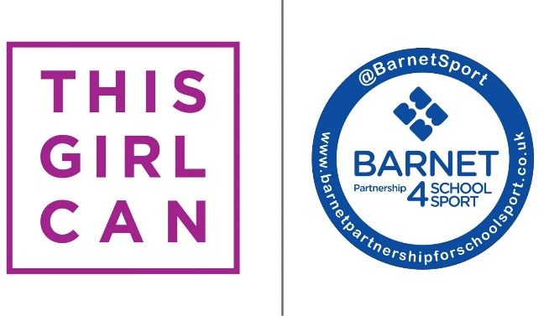

Why do you want to be a This Girl Can Leader?

What motivates you to get active?

Why is physical activity important?

Who are your role models that get you active and why?

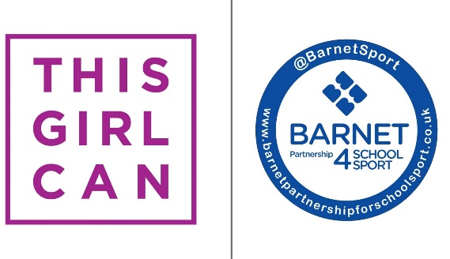

Stage 1 – What do girls want?

How could you find out what your female peers want?

Why is this important to know?

What can you do with your research?

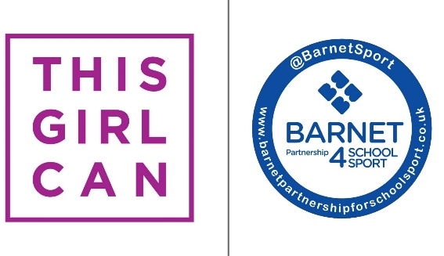

Stage 1 - Let’s find out
Design a questionnaire or interview to find out what your peers, family, teachers are doing to keep active during lockdown.
- Are you able to record your interview?
- Can you write up a news article/blog on your findings to share with your school?

What did your research find? How can this help you to get more girls active in your school?

Stage 2 – Create

TASK – How can you increase physical activity amongst girls at your school?

What ideas do you have to get female students at your school more active during lockdown? What did your research from Stage 1 tell you?

Create personal challenges

Ideas
Create a fitness channel on Youtube

Create a challenge for all of the girls to get involved in as a team

Choose one idea from your list
What will be your goal?
Use the SMART acronym to help you set realistic targets
S - Specific
M - Measureable
A - Achievable
R - Realistic
T - Timed

Stage 2 – Deliver
How can you monitor the success?

How will you promote your idea? How will you get girls involved?

What resources and help will you need?
- Will you work by yourself? In a group?
- How can you do this virtually?
- Will you need help from teachers, the BPSS team or family?

Create a timeline of how you will achieve your goal:
IDEA

ACTIVITY

Stage 3 – Celebrate and Success
What successes did you have?

What went well?

What did you enjoy the most?

What could be improved?
What feedback did you have?

What could you do differently next time?

