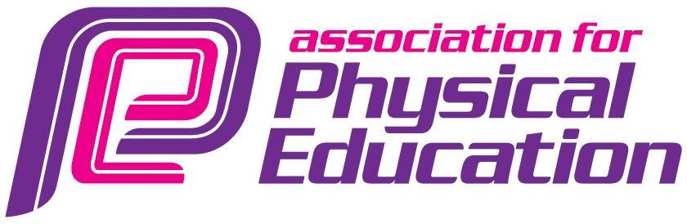

London Region
Secretary John I’Anson
139 Amyand Park Road
Twickenham
07880796174 E mail j.ianson45@btinternet.com

British Gymnastics Physical Education Teachers Trampoline Award Part 2
afPE is holding this course at Harris Academy, South Norwood.
On
Saturday 26th and Sunday 27th June 2021
9.30 a.m. – 4.30 p.m. each day
Please read the following notes very carefully
All delegates must be qualified teachers of physical education, students in their third or fourth year of training, a PGCE student, Schools Direct Trainee, SCITT or an Overseas Trained PE teacher.

It is a practical course and delegates are responsible for their own lunch and water on each of the days.

This course has taken all COVID precautions and further instructions will be provided on receipt of an application.

All delegates will be expected to attend on both days to achieve the award. There are only 9 places available on this course over the 2 days

The full course fee is £195.00 to include certification, BG resources.

Students, as described above, will receive a 25% discount and any afPE members will receive a 40% discount. Students who are afPE members will receive a 50% discount
All fees must be paid prior to the course

Application form for BG Teachers Trampoline Award Part 2
Harris Academy, South Norwood, Cumberlow Avenue, SE25 6AE

School/University:

Local Authority:

Name: D.f.E. Number:

E mail address: Mobile:

afPE membership number if applicable_____________________________

Address for invoice: (include telephone number and e mail address)

Please complete and return by e mail if possible or by post to the address at the top of this mail
John I’Anson
AfPE London Region Secretary
j.ianson45@btinternet.com
07880796174

Terms and Conditions
- Payment must be received prior to the commencement of the course. Some consideration for late applicants may be given.
- By applying for the course and taking receipt of the invoice you are entering into a contract with afPE London.
- Payment to be made within 25 working days (5 weeks) of receipt of the invoice.
- Any cancellation must be received 15 days prior to the start of the course in order to receive a refund.
- Any cancellation later than 15 days, except in exceptional circumstances, will incur half payment for the course.

