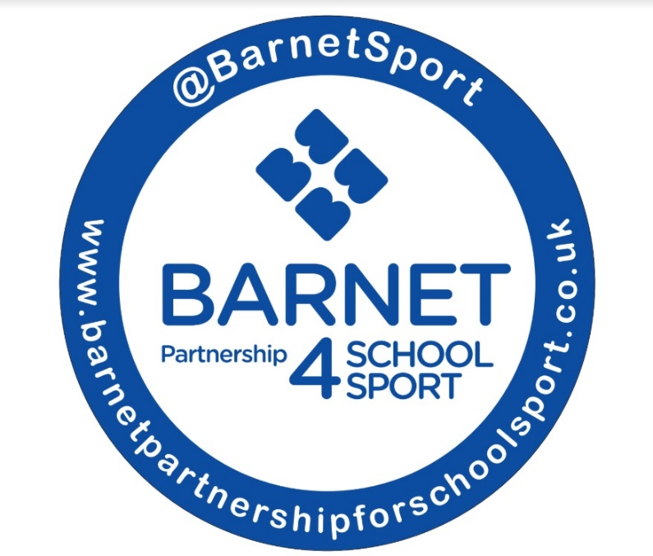

KS1 GAMES MARK

Application window runs from

3rd May 2023 – 26th July 2023

**How to apply for the KS1 Game Mark?**

Schools can create a presentation or document providing examples of how they have achieved each criteria. This can be through pictures, timetables, registers, newsletter extracts.

Please inform of us which level you are applying for when sending your application.

**Where to send the applications?**

Schools can send their application to [BPSS.Barnet@gmail.com](mailto:BPSS.Barnet@gmail.com)

**What happens after the application window?**

The BPSS team will go through applications and notify schools of their success. Schools will receive an award to recognise their achievements.

Bronze Award

* **We promoted 60 active minutes in our school**
* **We used a system to track young people’s participation in all extra-curricular physical activities and identify those not engaged**
* Collecting data through registers, spreadsheets, activity tracker
* **We have delivered one or more targeted opportunities for those young people who need it most**
* Targeted clubs/Change 4 Life club registers
* **We were committed to delivering positive experiences for young people**
* Selecting appropriate children to attend BPSS festivals
* **We were aware of the term physical literacy as a school.**
* **We involved at least 50% of children in each of Year 1 & 2 in the virtual challenge**
* Schools do not need to enter their results, this can be intra school

Silver Award

* **We promoted 60 active minutes in our school**
* **We used a system to track young people’s participation in all extra-curricular physical activities and identify those not engaged**
* **We have delivered two or more targeted opportunities for those young people who need it most**
* **We were committed to delivering positive experiences for young people**
* **We promoted the use of physical literacy at our school.**
* **We involved at least 75% of children in each of Yrs 1 & 2 in the virtual challenge**
* **We offered a form of sports leadership or playground helper opportunities within Yr2**
* School or BPSS leadership training
* **We entered a minimum of 2 inter competition/festival events during the academic year**
* Can include the BPSS Dance Festival
* Does not have to be BPSS events

Gold Award

* **We actively engaged our students in 60 active minutes in our school**
* **We used a system to track young people’s participation in all extra-curricular physical activities and identify those not engaged**
* **We have delivered two or more targeted opportunities for those young people who need it most**
* **We have committed to delivering positive experiences for young people**
* **We activity demonstrated physical literacy at our school.**
* **We involved 100% of children in each of Years 1 & 2 in the virtual challenge league and forwarded top entries into the Yr1 & 2 virtual challenges at Inter level**
* **We offered sports leadership opportunities to all Yr2 children**
* **We have entered a minimum of 3 inter competition/festival events during the academic year (this can include the BPSS DanceFestival)**
* **We hosted a KS1 event which included one other KS1 school**
* **We understood the importance and value of pupil voice at our school**

Platinum Award

**Schools are able to apply for platinum award if they have achieved the KS1 Gold Mark in 3 consecutive years (2016-17, 2017-18, and 2018-19)**

**Schools must achieve the gold criteria as well as providing a short report on the impact & achievements in PE & physical activities within the school at KS1 level.**